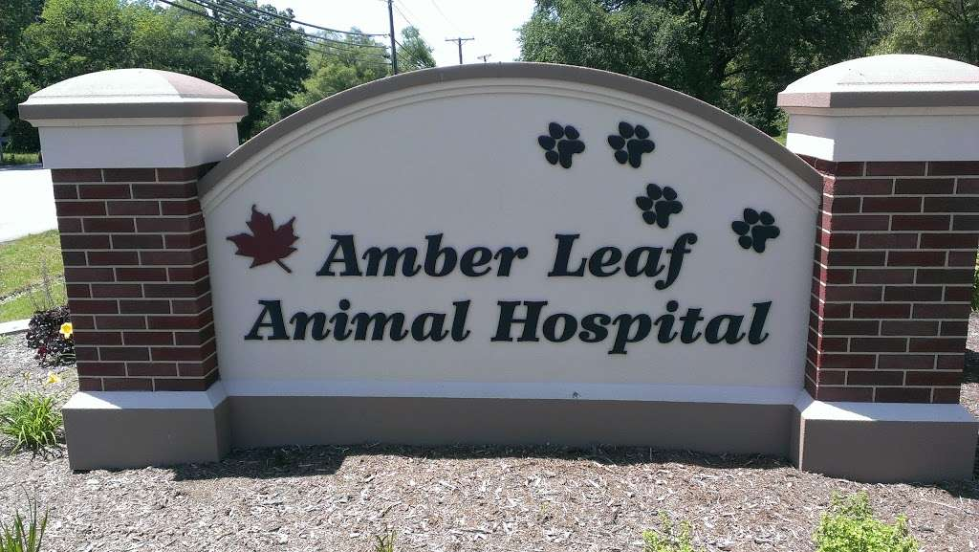



We are looking for Receptionist & Vet Techs **(Will Train)**

[*https://amberleafah.com*](https://amberleafah.com)

28W730 Roosevelt Rd., Winfield, IL