***Science Student Safety Eyewear for Online Purchase***

***Online sales only...no money will be taken at school.***

Even though our goggles are sanitized after every use, some students may want the option of owning their own personal goggles for Science class. We currently have two different models for students to purchase depending upon preference. See below for information and cost of both types. Students can stop by the Science Division Head, Mr. Albright’s office (room 2440) to see both models or ask their current Science teacher. Sales will continue until goggles are sold out. When one model sells out, students’ only choice is to purchase the remaining model.

[**LINK TO PURCHASE**](https://d94.revtrak.net/supplies-for-science-class/#/v/science-student-safety-eyewear)

**Flinn Chemical Splash Goggles: $5.50**

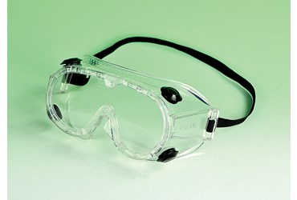

# **Flinn VisorGog Safety Goggles: $7.50**

